SMART Board
Set-up instructions for Sanborn 313 in 4 easy steps
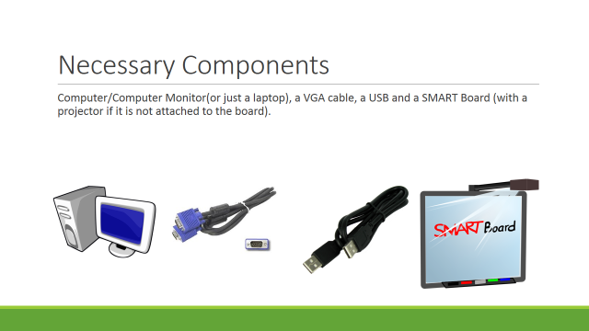
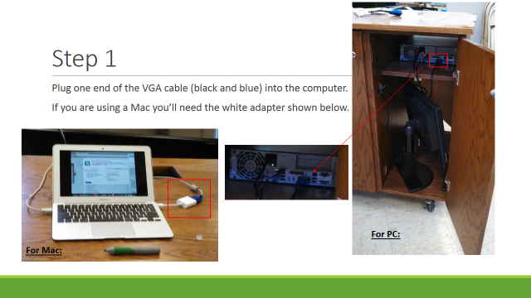
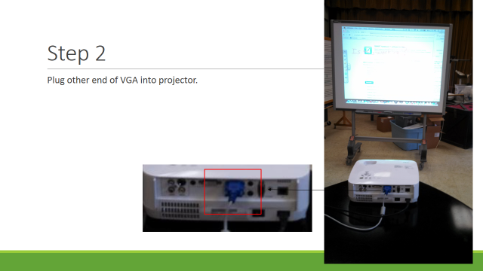
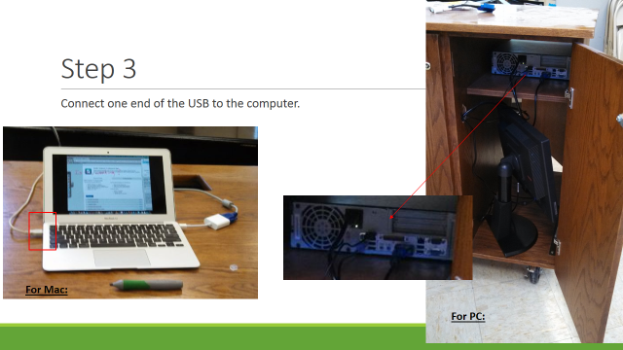
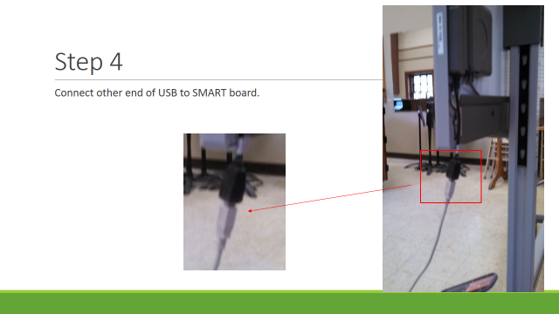
You will need the SMART Product Drivers and SMART Notebook software on your computer to use the board. These may be downloaded from smarttech.com/us/Support/Browse+Support/Download+Software

That should do it! Just turn everything on and you are ready to go. If you have any additional questions visit helpdesk.owu.edu/hardware/smart-board/ or contact the Help Desk at x3120 or helpdesk@owu.edu.

