Using SQL Server Reporting Services

SQL Server Reporting Services (SSRS) is the main reporting tool that will be used to view reports from Power Campus and, in time, some of our other new campus systems. It will replace Cognos as our main reporting tool and for report consumers it is even easier to use. All you need to use SSRS is Internet Explorer and a valid login to our campus network.

To use SSRS to view reports:

- Open Internet Explorer.
- Go to https://phoenix/Reports/Pages/Folder.aspx. You will see a screen similar to the one below. The folders you will be able to see will be governed by security set up within SSRS.

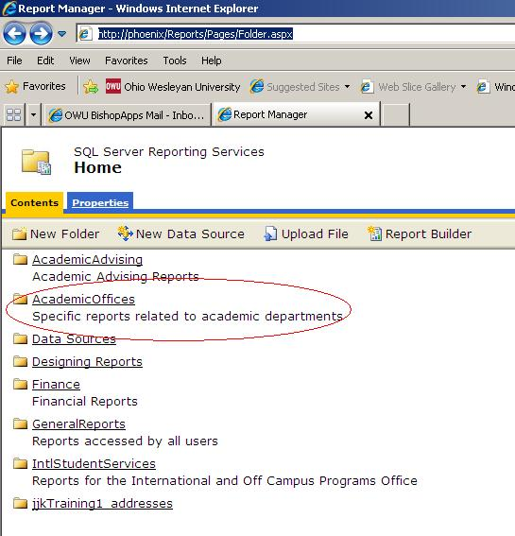

- Next. Click the desired folder to view available reports.

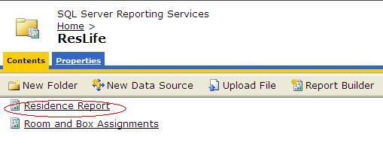
- Click on the report you’d like to run. Enter any required information in the boxes provided.
Click on the “View Report” button on the right hand side of the screen.
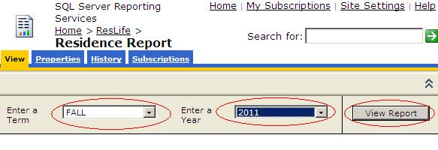
- Once the report runs you will see some options you can use to find,print or save the information in the report.
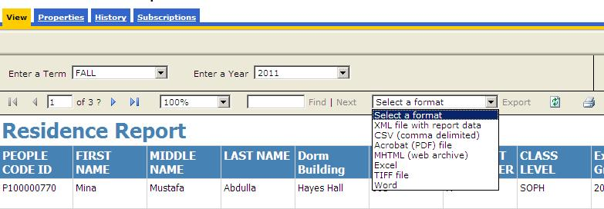

To Save Your Report

- To Save your report select a desired report format. Excel, Word, Acrobat (PDF) file, or CSV (comma delimited) will be the most useful options.

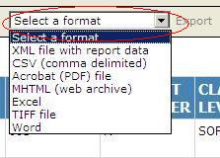

- Once you have chosen a format notice word “Export” turn from gray to a light blue. Click it.
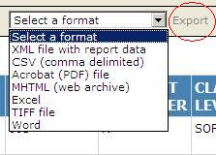

- You will get a box that asks you if you want to Run, Save or Cancel. Choose Save. Enter the name you’d like to give the report and a location where you’d like the report to be saved.
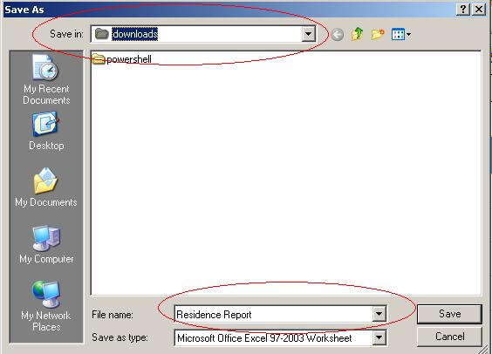

To Scroll Through a Report, Find Information, Resize, Refresh or Print

- If you want to quickly browse a report you can use the arrow buttons on the leftmost side of the report options bar.
  - The Right arrow advances to the next page.
  - The Left arrow advances to the prior page.
  - The right arrow with a bar will take you to the end of the report.
  - The left arrow with a bar will take you to the beginning of a report.
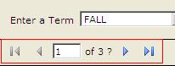

- If you want to find specific information in a report such as an ID you can use the text search box with the Find | Next options. Just enter the text you want to search for and click “Find”. To continue searching for the next occurrence of the string click “Next”
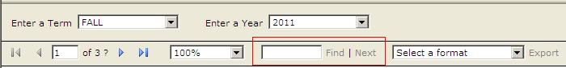

- You can resize a report by selecting a new percentage in the resize dropdown box, Refreshing a report can be done with the icon to the right of the word “Export”. Printing can be done by clicking the printer icon. Be sure of how long a report is before using this option.

