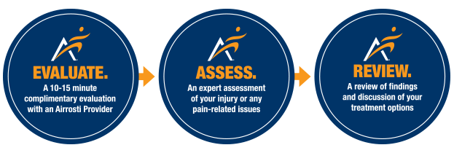

**- - - - - - - - - - - - - - - - - - - - - - - - - - - - - - - - - - - - - - - - - - - - - - - - - - - - - - - - - - - - - - - - - - - - - -**

FREE INJURY ASSESSMENTS

At Ohio Wesleyan University

FRIDAY, DECEMBER 6th

11AM to 2PM

**[cid:image001.png@01D2350B.67EC7DB0](https://go.airrosti.com/scheduler/event/2D04THG0O7H)**

**- - - - - - - - - - - - - - - - - - - - - - - - - - - - - - - - - - - - - - - - - - - - - - - - - - - - - - - - - - - - - - - - - - - - - - - -**

**We’re here to help.**

At Airrosti, we focus on identifying the root cause of our patients’ pain, then resolving that pain as quickly as possible—in an average of **3 VISITS** (based on patient reported outcomes). If you’re suffering from pain or unresolved injuries, we invite you to join us for a **COMPLIMENTARY, NO OBLIGATION** injury assessment from one of our Airrosti Providers.

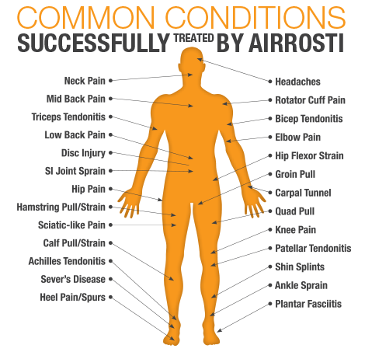

**Call for priority scheduling or register the day of the event (subject to availability):**

**(855) 283-2457 | AIRROSTI.COM**

This complimentary injury assessment is for educational purposes and is not intended to induce a paying visit, nor does it require any individual to schedule an appointment with an Airrosti Certified Provider. You are free to seek an opinion from the health care provider of your choice for a more thorough examination and treatment.  All of the component services of  this assessment that will be provided to you at no charge include a clinical guideline evaluation along with a report of findings. We will charge for any additional services provided to you in the future.